**Subtract-Questions**

Key Stage 3: 2003 Paper 1 Level 3-5

1.

2.

Key Stage 3: 2003 Paper 2 Level 3-5

3.

Key Stage 3: 2003 Paper 1 Level 4_6

4.

5.

6.

Key Stage 3: 2004 Paper 1 Level 3-5

7.

8.

9.

Key Stage 3: 2004 Paper 2 Level 3-5

10.

Key Stage 3: 2004 Paper 1 Level 4-6

11.

Key Stage 3: 2005 Paper 1 Level 3-5

12.

13.

Key Stage 3: 2005 Paper 2 Level 3-5

14.

15.

16.

17.

Key Stage 3: 2005 Paper 1 Level 4-6

18.

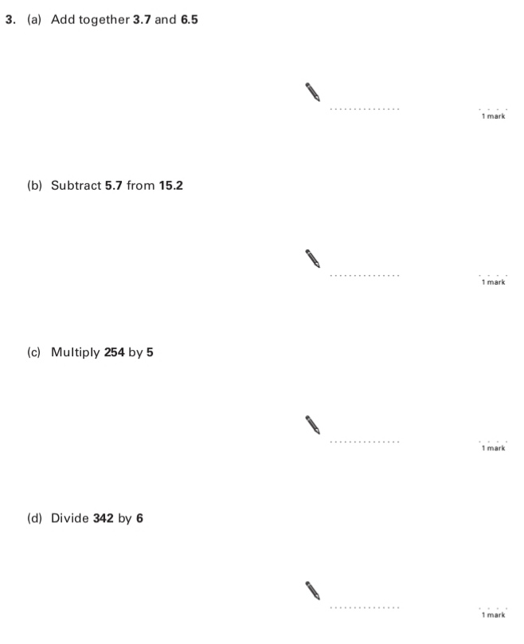

19.

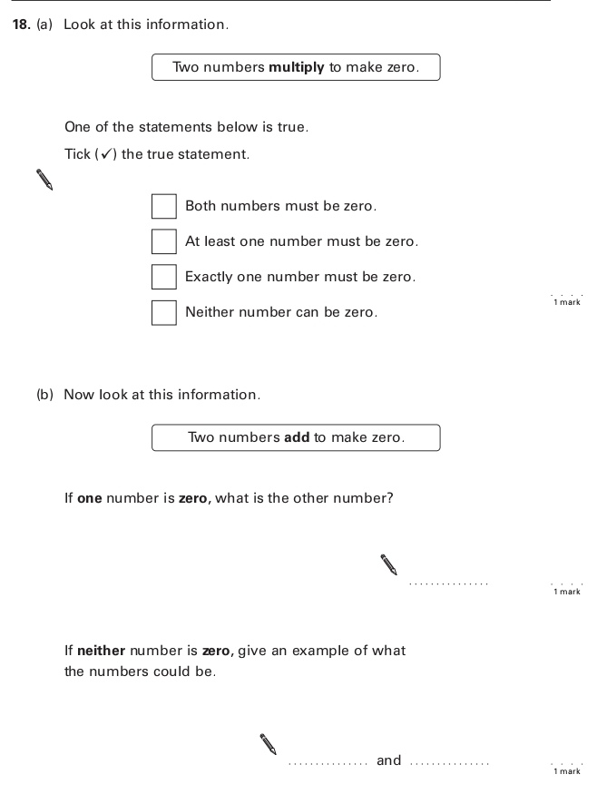

Key Stage 3: 2005 Paper 2 Level 4-6

20.

Key Stage 3: 2006 Paper 1 Level 3-5

21.

Key Stage 3: 2006 Paper 2 Level 3-5

22.

23.

Key Stage 3: 2006 Paper 2 Level 4-6

24.

Key Stage 3: 2007 Paper 1 Level 3-5

25.

Key Stage 3: 2007 Paper 2 Level 3-5

26.

Key Stage 3: 2007 Paper 2 Level 4-6

27.

Key Stage 3: 2008 Paper 1 Level 3-5

28.

29.

Key Stage 3: 2009 Paper 1 Level 3-5

30.

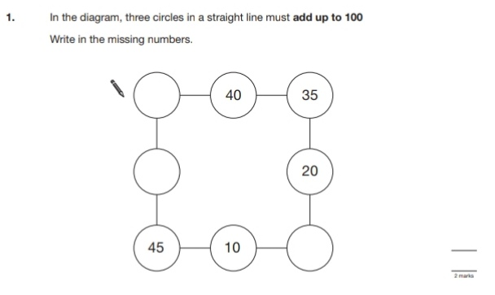

31.

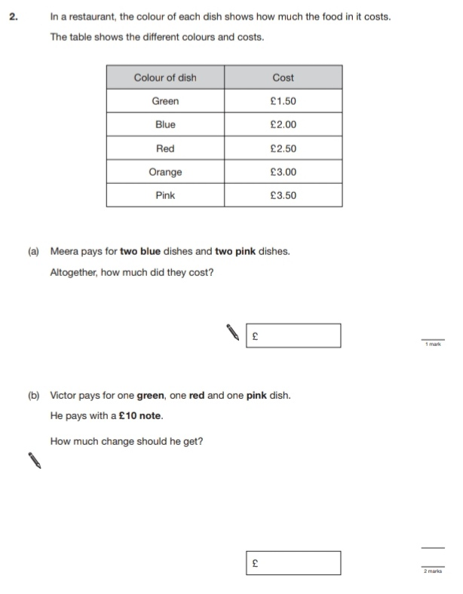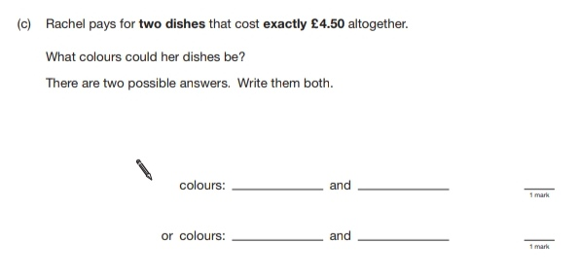

32.

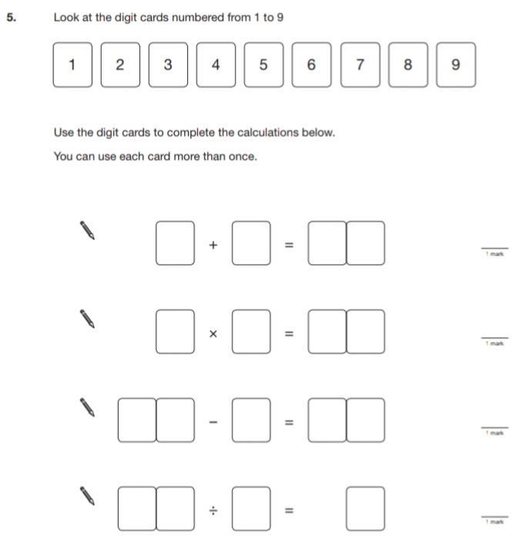

33.

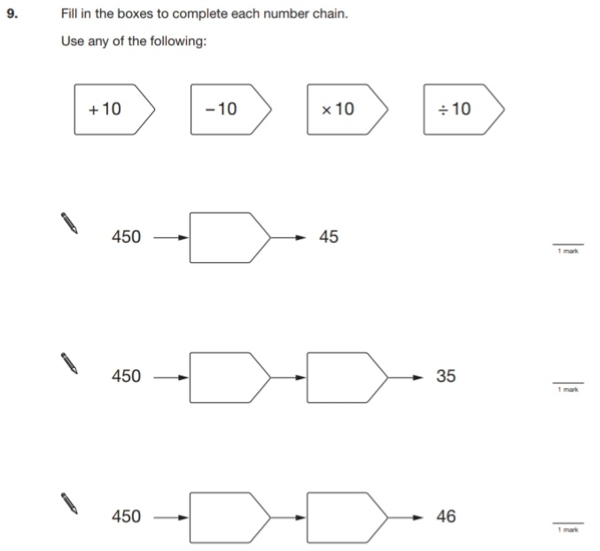

34.

Key Stage 3: 2009 Paper 2 Level 3-5

35.

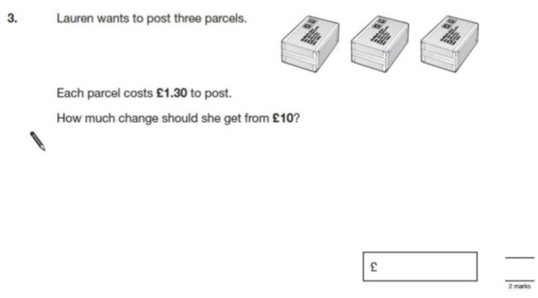

36.

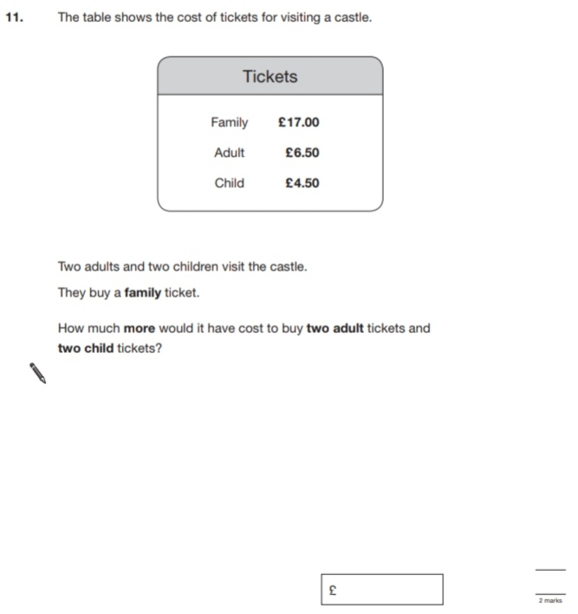

37.

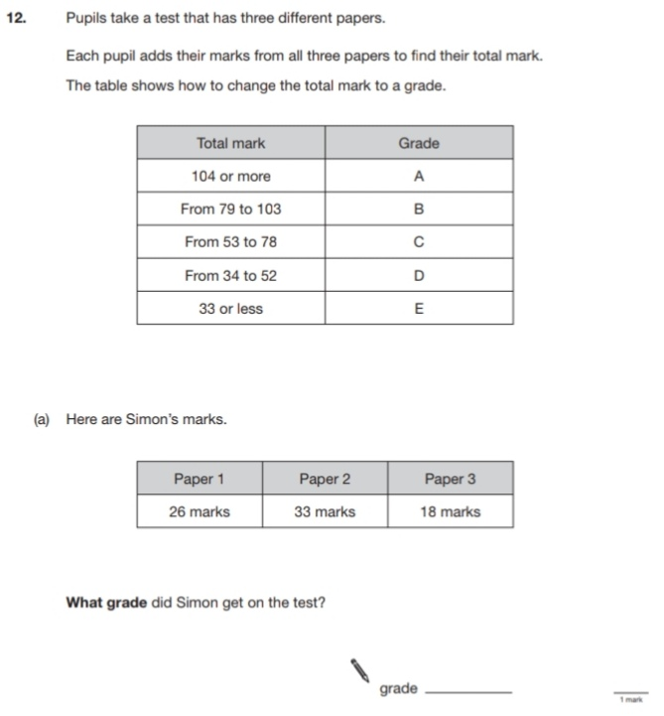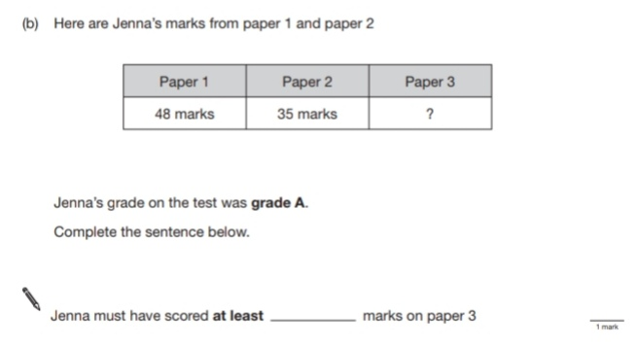

Key Stage 3: 2009 Paper 1 Level 4-6

38.

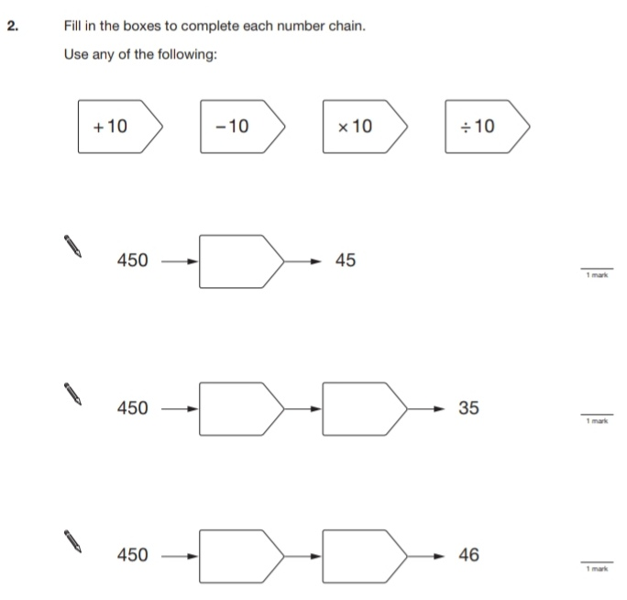

39.

40.

41.

Key Stage 3: 2009 Paper 2 Level 4-6

42.

43.

Key Stage 3: 2010 Paper 1 Level 3-5

44.

45.

46.

Key Stage 3: 2010 Paper 2 Level 3-5

47.

48.

Key Stage 3: 2010 Paper 1 Level 4-6

49.

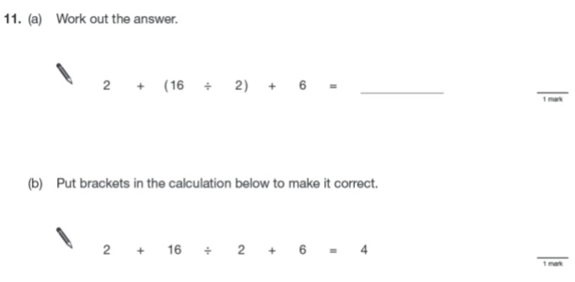

50.

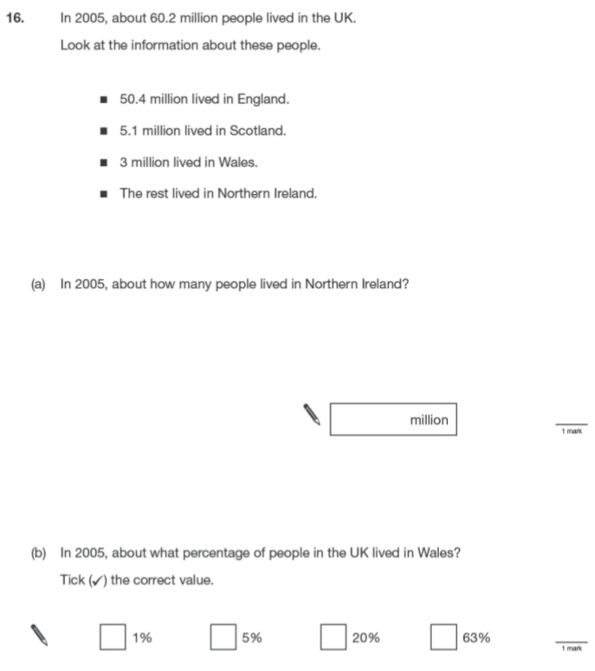

Key Stage 3: 2010 Paper 2 Level 4-6

51.

52.

Key Stage 3: 2011 Paper 1 Level 4-6

53.

